# A close up of a logo

# Dynamics 365 Customer Insights

Lab 3: Verify the Environment

Contents

Step 1 – Connect to the Power Platform Admin portal 3

Step 2 – Connect to the Customer Insights Portal 5

## Approximate Time to Complete – 10 mins

Note: This lab assumes the Dynamics 365 environment has already been provisioned and configured for this course. If this is not the case, please complete the steps in Appendix A to set up your environment, then return to this lab to validate it.

# Step 1 – Connect to the Power Platform Admin portal

In this course, you will use the Power Platform Admin portal to support your work with Customer Insights. Verify that you can connect to the portal. In this step, use the credentials provided to you by your instructor or the course facilitator.

To visit the Power Platform Admin portal. open an “in private” browser window and navigate to <https://admin.powerplatform.microsoft.com/>. Fill in your email address and click **Next.**

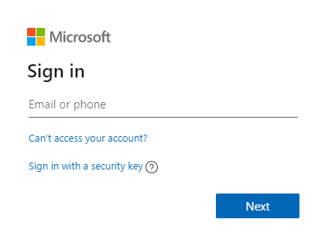

On the next screen, enter your assigned password and click **Sign in.** If you are asked to stay signed in, click **Yes.**

Review the admin center interface. Note the environment names. You will return to the admin center in labs later in this course.

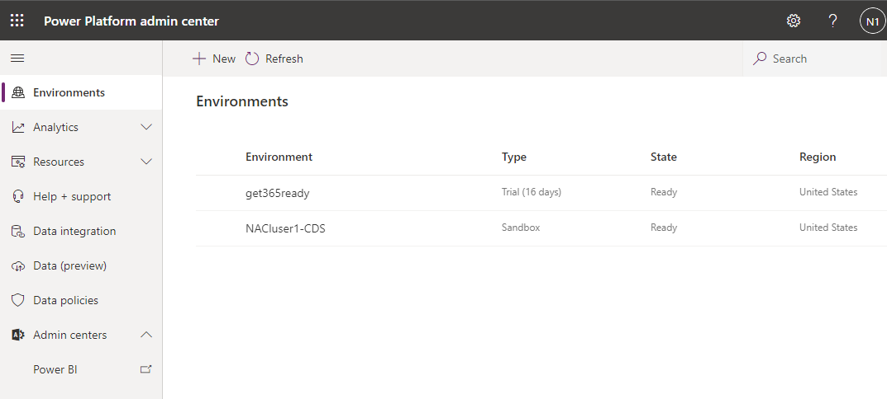

# Step 2 – Connect to the Customer Insights Portal

Now that you have verified that you can connect to the Power Platform Admin portal, connect to the Customer Insights environment. You will use the same credentials as in Step 1.

From your private browsing window, open a new tab and navigate to <https://home.ci.ai.dynamics.com/>. If prompted to log in, use the same credentials as in Step 1.

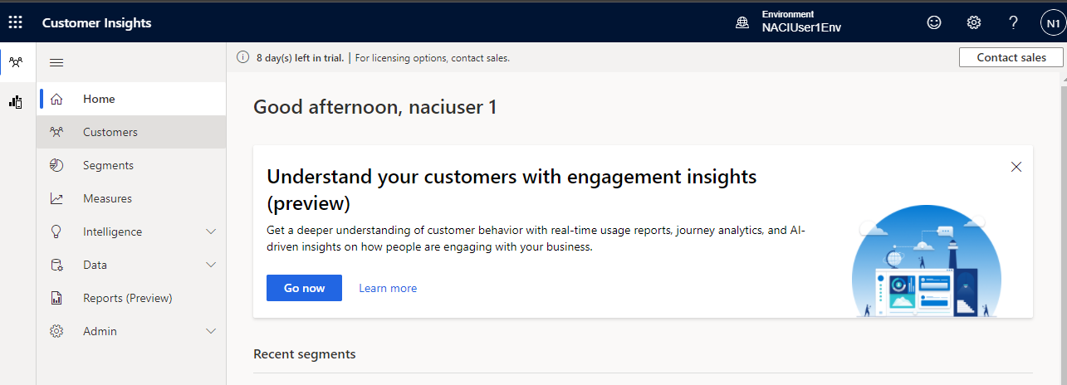

Once you have successfully connected, observe the **Home** page. You will do most of your Customer Insights data ingestion and manipulation using the tabs on this site.

If you have successfully connected to the Power Portal Admin center, and to the Customer Insights home page, you have completed this lab.